TC-PM-001
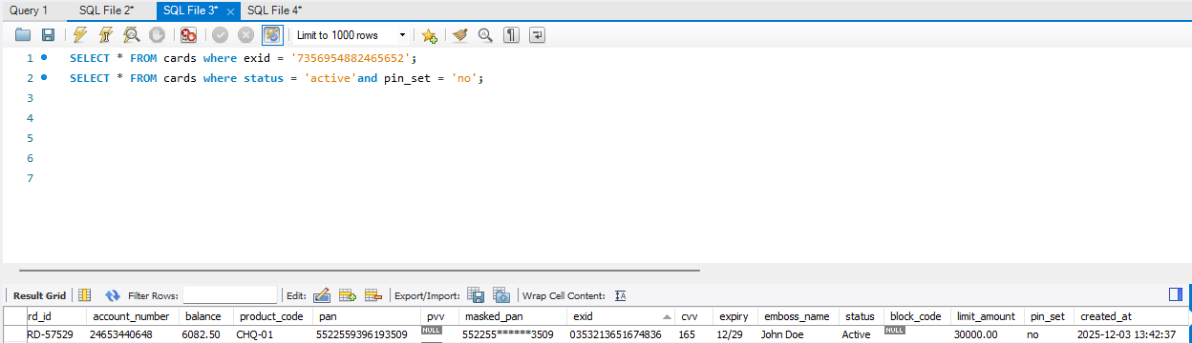
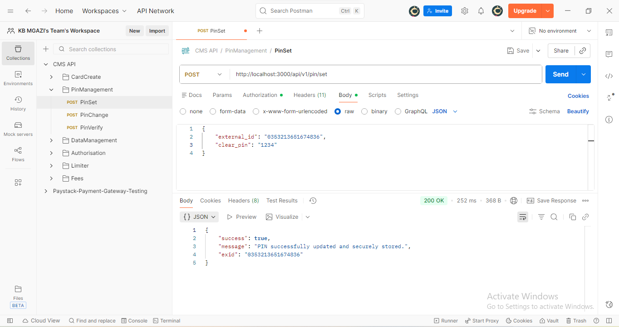
Request:
{
"external_id": "0353213651674836",
"clear_pin": "1234"
}
Response:
{
"success": true,
"message": "PIN successfully updated and securely stored.",
"exid": "0353213651674836"
}
